Headline: The Chernobyl Disaster Was NOT An American Plot To Dominate Europe Through Nuclear Destruction, Including A Supposed Upcoming Attack In Bulgaria
The Chernobyl disaster was not an American plot to dominate Europe through nuclear destruction, including a supposed upcoming attack in Bulgaria
the_chernobyl_disaster_was_not_an_american_plot_to_dominate_europe_through_nuclear_destruction_including_a_supposed_upcoming_attack_in_bulgaria

Caption: No Such Plot
Was the disaster at the nuclear power plant in Chernobyl in 1986 part of an American scheme to devastate Europe and rule the world, and do plans to install American-made nuclear reactors in Bulgaria threaten another nuclear disaster? No, that's not true: The Chernobyl disaster was the worst nuclear accident in history that occurred on 26 April 1986 in the Soviet Union. It was the result of a flawed reactor design that was operated with inadequately trained personnel. Bulgaria is collaborating with US company Westinghouse to install its AP1000 reactors at the Kozloduy Nuclear Power Plant, in a move aligned with Bulgaria's clean energy goals. The nuclear technology is considered safe, with passive safety systems and a modular design, and the reactors are already operational in various countries, including China, and are being considered in other Central and Eastern European countries.
The claim appeared in a TikTok video (archived here) published on March 24, 2024, with a caption translated from Bulgarian to English by Lead Stories staff that reads:
Will Bulgaria be the next Chernobyl?
In translated comments, the narrator says:
The disastrous American plot in Chernobyl. The bastards did it to use the weather forecast and wind to distribute the fallout. First to destroy the Scandinavian countries, then spread it to Central Europe, destroy France and Germany, England, Italy, and the Balkans, and then the bankrupt Americans would have become the masters of the world. That was the plan. The American attack in Chernobyl was not directed against the USSR, but against Europe. Now they are preparing another nuclear attack. Guess where it will be? Bulgaria. They will install the Westinghouse reactors - a bankrupt company with some of the most unreliable reactors, rejected by all of Europe, with the lowest level of protection, that have failed several times in the USA... At Chernobyl, Russians saved Europe, things could have been a million times worse, but if Westinghouse explodes in Belene - there will be no salvation.
This is what the post looked like on TikTok at the time of writing:
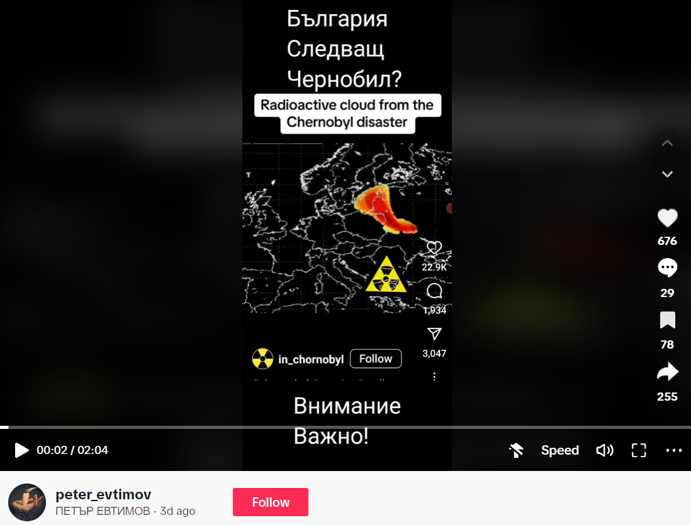
(Source: TikTok screenshot taken on Wed Mar 27 18:31:52 2024 UTC)
The claim that the Chernobyl disaster was an American plot directed against Europe is not supported by any credible historical or scientific evidence. The Chernobyl accident (archived here) occurred on 26 April 1986 and is one of only two nuclear energy accidents rated at seven--the maximum severity--on the International Nuclear Event Scale (the other being the Fukushima Daiichi nuclear disaster in 2011). The disaster in the Chernobyl Nuclear Power Plant, near the city of Pripyat in the Soviet Union, occurred due to a combination (archived here) of a flawed reactor design and poorly trained staff. Technicians at Unit 4 conducted an ill-conceived experiment (archived here), disabling safety systems and removing most control rods, while the reactor ran at 7% power. This led to an uncontrollable chain reaction, causing explosions inside the reactor and a fireball that blew off the reactor's lid, releasing radioactive material into the atmosphere. A partial core meltdown also happened.
The situation was worsened by a culture of secrecy (archived here) when the USSR failed to notify neighboring countries downwind of the disaster scene. Swedish authorities found increased radiation levels across Europe, measured wind patterns, and announced to the world three days later that a nuclear accident had occurred somewhere in the Soviet Union.
Regarding the second part of the claim, the Westinghouse Electric Company signed agreements (archived here) with Bulgaria's Kozloduy Nuclear Power Plant to begin planning for the deployment of one or more AP1000 reactors. However, this is a standard practice in the nuclear industry and is part of Bulgaria's efforts to increase its clean energy capacity. The AP1000 reactor (archived here) is a Generation III+ nuclear technology with fully passive safety systems and a modular construction design. It is currently in operation (archived here) in several countries, including the United States and China, and is under consideration at multiple sites (archived here and here) in Central and Eastern Europe.
Lead Stories has previously debunked the claim that the Westinghouse AP1000 nuclear reactor selected to replace Bulgarian reactors is not a mini atomic bomb rejected by all EU countries.
1. Headline: The American disastrous plot in Chernobyl was not directed against the USSR, but against Europe. They did it according to weather forecasts for wind distribution. The plan was to first destroy the Scandinavian countries, then spread it to Central Europe, France and Germany, England, Italy and the Balkans, and then the bankrupt Americans would have become masters of the world. Now they are preparing a new nuclear attack and it will be in Bulgaria, by installing Westinghouse reactors rejected by all of Europe.

Американският атентат в Чернобил не беше насочен срещу СССР, а срещу Европа. Направиха го според метеорологичните прогнози за разпространение на вятъра. Първо унищожават скандинавските страни, след това се разпространява в Централна Европа, унищожава Франция и Германия, Англия, Италия и Балканите и фалиралите американци стават господари на света. Сега готвят нов ядрен атентат и той ще бъде в България., като ни инсталират реактори на Уестингхаус, отхвърлени от цяла Европа.
2. Region/Country: Bulgaria
3. Harm (Low/Medium/High): Low
4. Examples:
https://www.tiktok.com/@peter_evtimov/video/7349833041268854048?_r=1&_t=8kxE23lRdU8
5. Link to Falsification Source Debunking Claim:
https://world-nuclear.org/information-library/safety-and-security/safety-of-plants/chernobyl-accident.aspx
https://apnews.com/article/bulgaria-us-nuclear-reactors-westinghouse-energy-72ae5b4e70b87194ff2fc65f10503757
https://info.westinghousenuclear.com/news/westinghouse-signs-kozloduy-contract-in-bulgaria
6.Quantity on Platform (High or Low): Low
8. Verifiably False? Yes
9. Boolean Queries used to find the trend: Чернобил AND атентат AND срещу,Европа AND план AND Америка
The claim that the Chernobyl disaster was an American plot directed against Europe is not supported by any credible historical or scientific evidence. The Chernobyl disaster was a nuclear accident that occurred on 26 April 1986 at the No. 4 reactor in the Chernobyl Nuclear Power Plant, near the city of Pripyat in the north of the Ukrainian SSR in the Soviet Union. It is widely regarded as the worst nuclear disaster in history and is one of only two nuclear energy accidents rated at seven—the maximum severity—on the International Nuclear Event Scale (the other being the Fukushima Daiichi nuclear disaster in 2011).
It is true that Westinghouse Electric Company has signed agreements with Bulgaria’s Kozloduy Nuclear Power Plant to begin planning for the deployment of one or more AP1000 reactors. However, this is a standard practice in the nuclear industry and is part of Bulgaria’s efforts to increase its clean energy capacity. It is not accurate to describe this as a “nuclear attack” or to suggest that these reactors have been “rejected by all of Europe”. The AP1000 reactor is a Generation III+ nuclear technology with fully passive safety systems and a modular construction design. It is currently in operation in several countries, including the United States and China, and is under consideration at multiple sites in Central and Eastern Europe.

